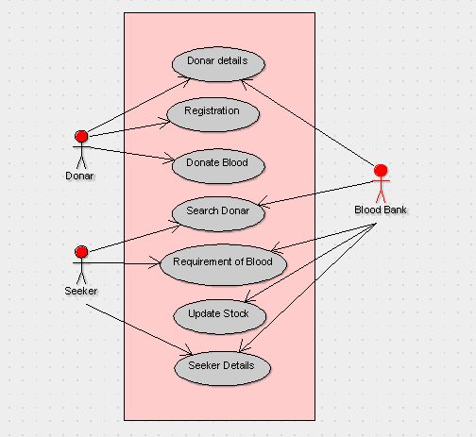

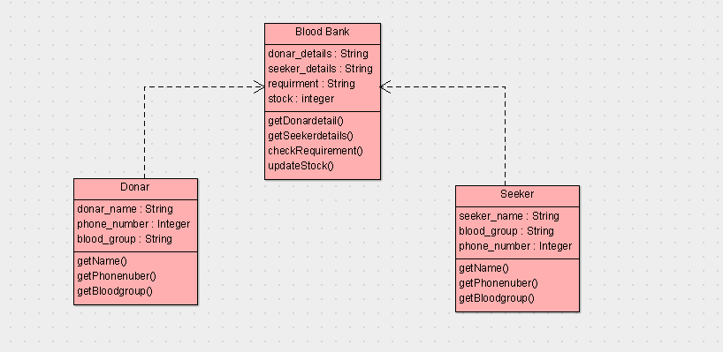

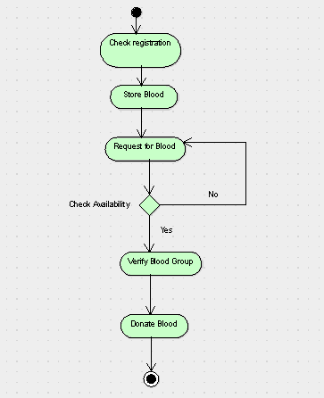

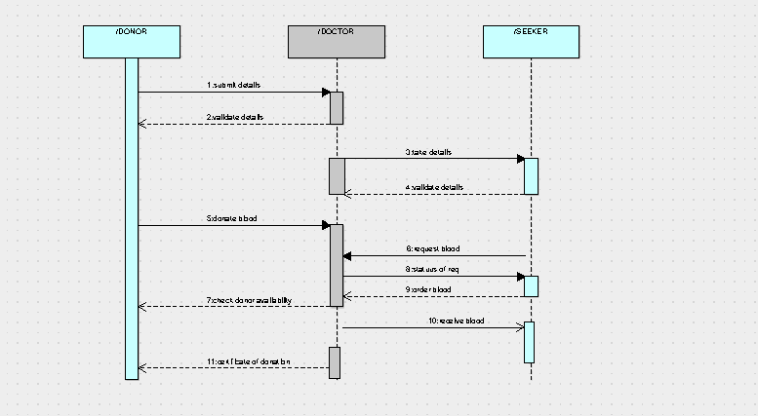

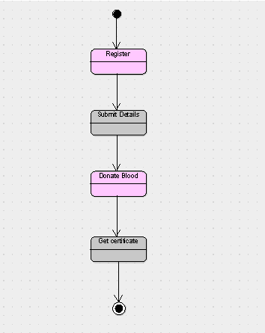

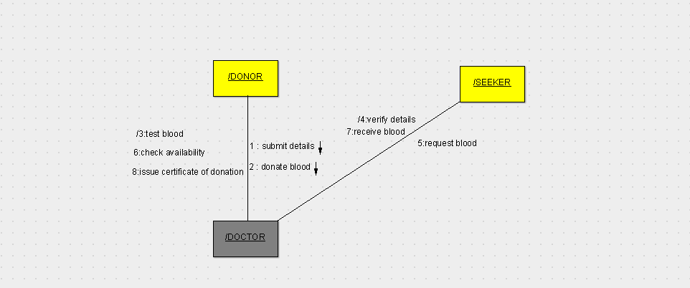

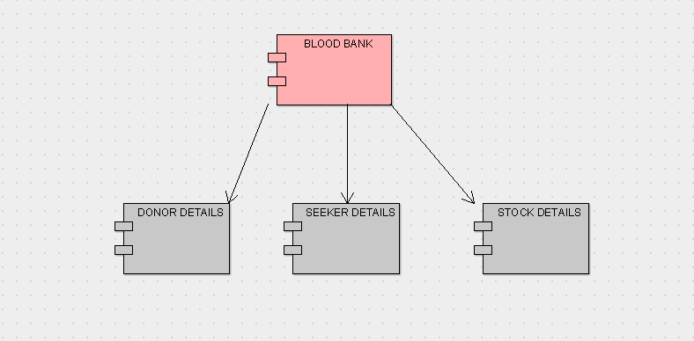

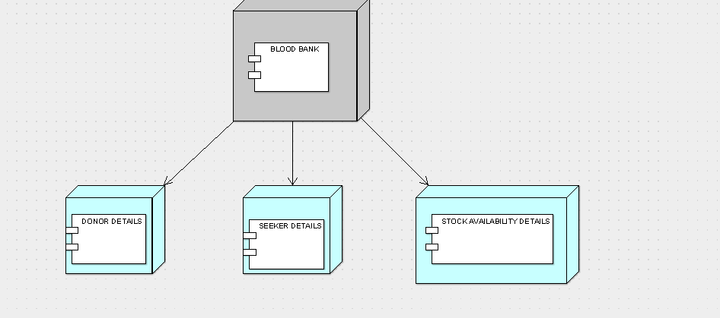

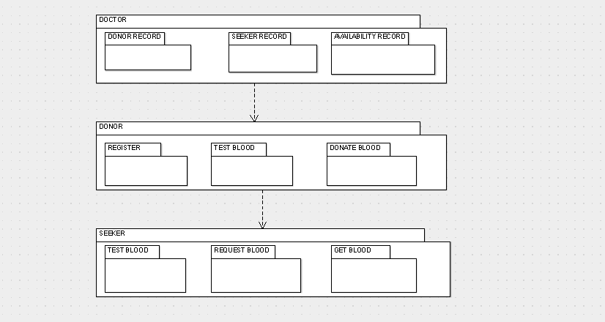

public class Blood Bank {

  public String donar_details;

  public String seeker_details;

  public String requirment;

  public integer stock;

  public void getDonardetail() {

  }

  public void getSeekerdetails() {

  }

  public void checkRequirement() {

  }

  public void updateStock() {

  }

}

public class Donar {

  public String donar_name;

  public Integer phone_number;

  public String blood_group;

  public void getName() {

  }

  public void getPhonenuber() {

  }

  public void getBloodgroup() {

  }

}

public class Seeker {

  public String seeker_name;

  public String blood_group;

  public Integer phone_number;

  public void getName() {

  }

  public void getPhonenuber() {

  }

  public void getBloodgroup() {

  }

}